To: Professor Stephen Coggeshall  
From: Alok Abhishek   
Date: 03/3/2018  
Subject: DSO 562: Fraud Analytics – Application data DRQ

# Data Quality Report: Application data set

**Data Description:** The data is anonymized data to represent application for services such as (telephone connection, credit card).

There are 94866 records and 29 columns with total data size of 8.3 MB.

**Data Summary:**

Data does not have missing value as we can see from heat map of missing values in the data set.

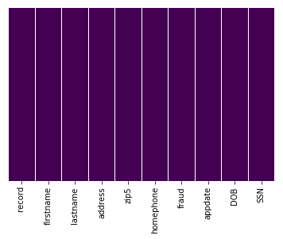

**Also, from correlation plot we can see that there is no correlations in between different variables.**

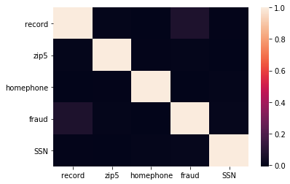

**First Name:**



**Most Common 1st names for application:**



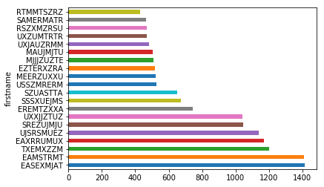

**Last Name:**





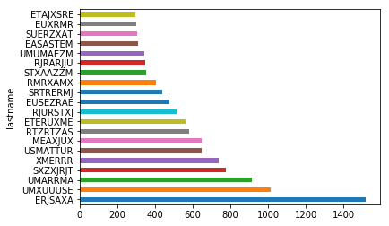

**Address:**





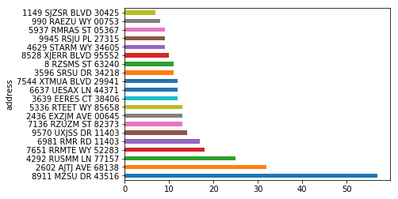

**ZIP 5:**



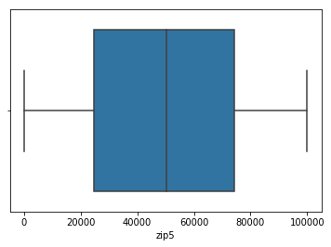

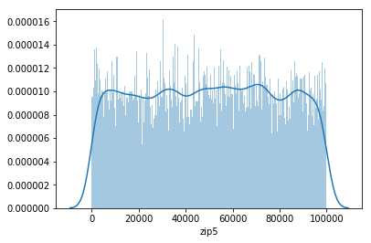

**Most frequent Zip codes used in the application:**



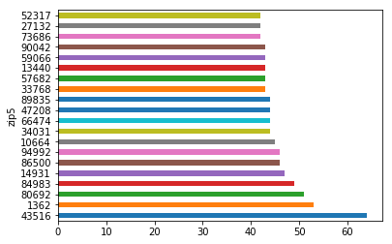

**Home Phone:**





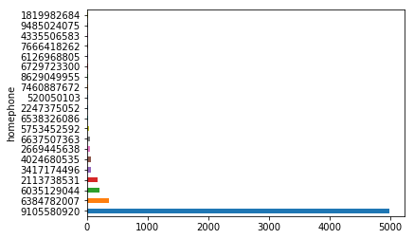

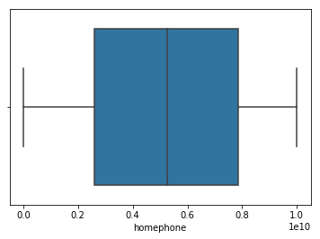

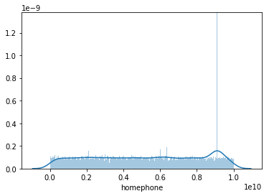

**Fraud:**



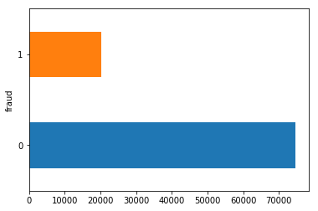

**Application Date:**



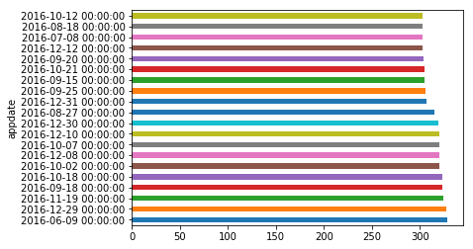

**Date of Birth:**





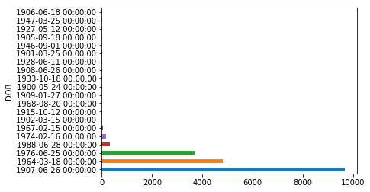

**SSN:**



